How to use the on-line giving website
Table of Contents
Signing up 2
Making a contribution 7

Signing up

Navigate to Http://www.atlgoc.org and click on the “Stewardship” drop down menu and then “Become a Steward” where you will see the “Donate Now with on-line giving” icon, which you may click upon.

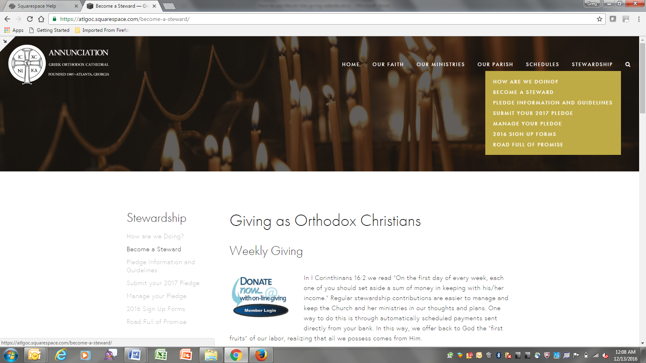

After you click on the “Donate Now with on-line giving” icon…you will then be shown the following access screen…
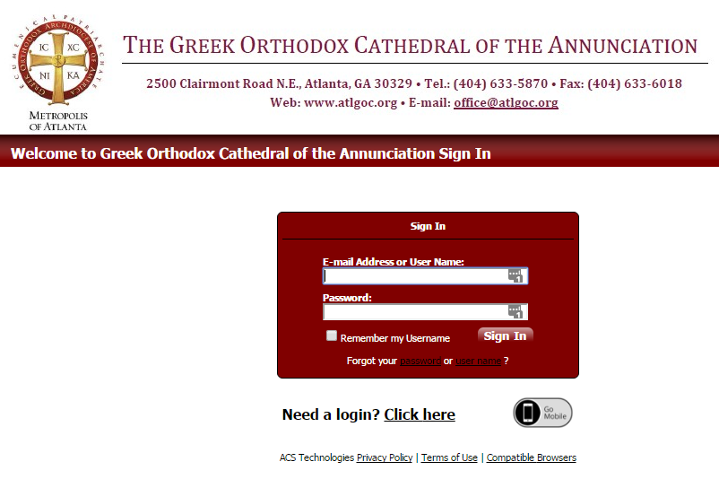

Input your email address that the church uses to contact you.

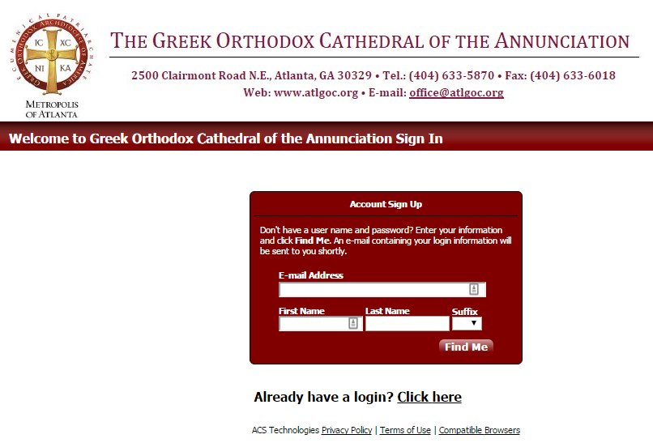

If you do not know what to enter in to the entry areas of the Sign In, please contact the church office.

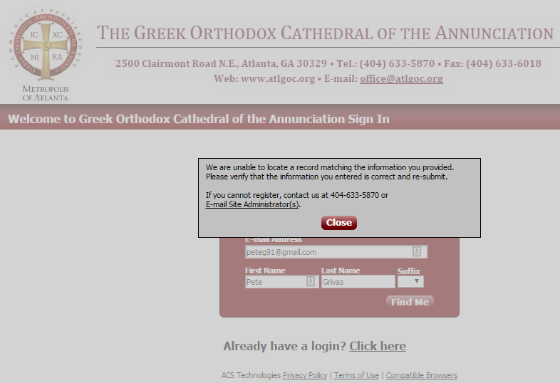

Go to your email account and find the automated email and click the link provided

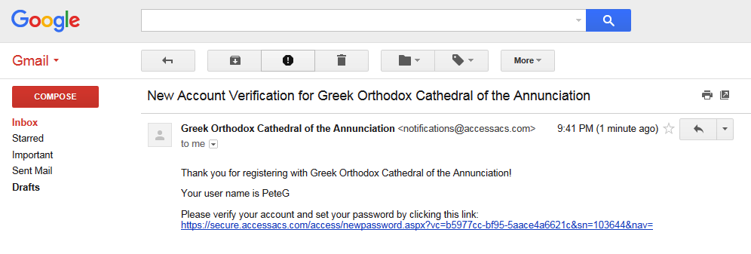

Making a contribution
Sign in and click on “Giving” and “Give Now”
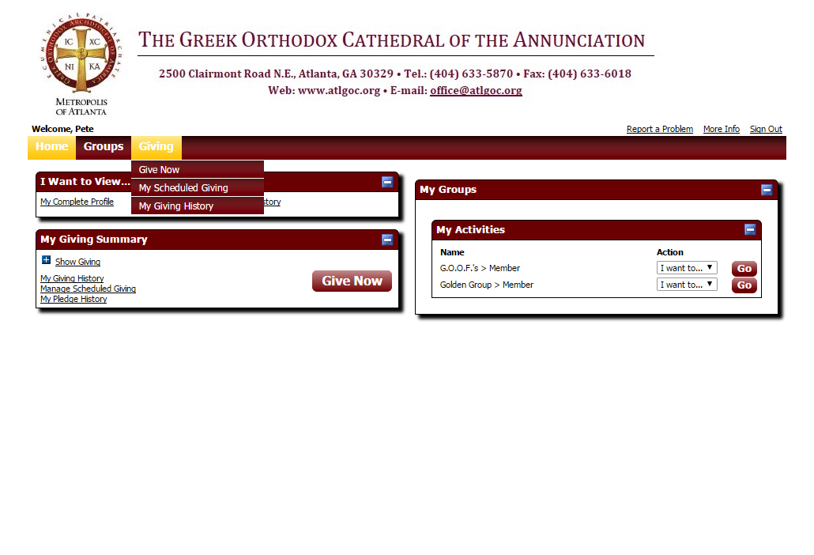
From here you can choose if you want to make a one-time contribution…
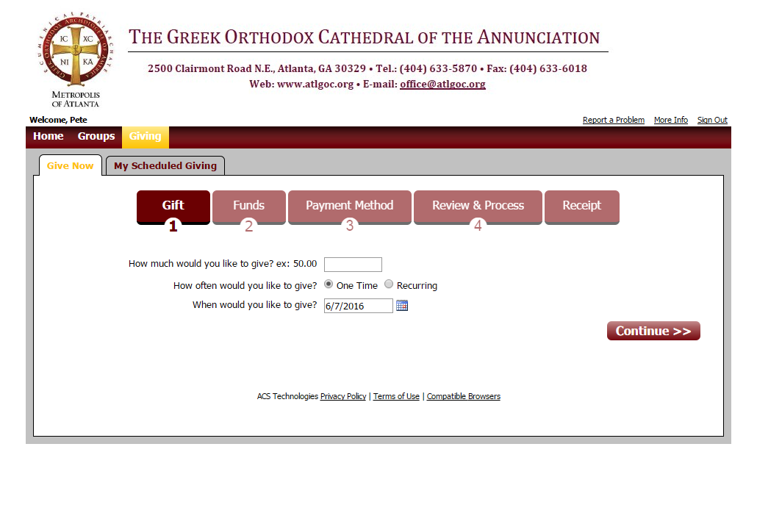
…or a recurring contribution. This recurrence can always be adjusted as your pledge changes year to year.
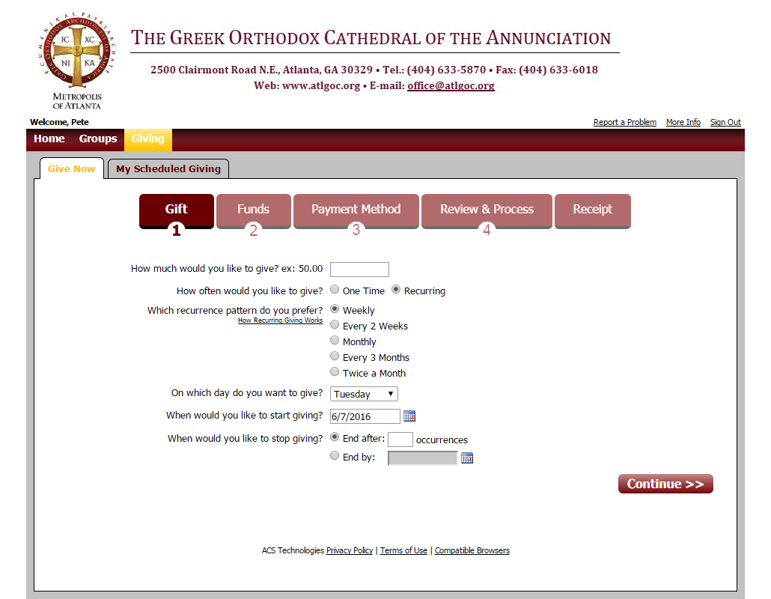
From the “Giving” menu you can also see your pledge history and progress
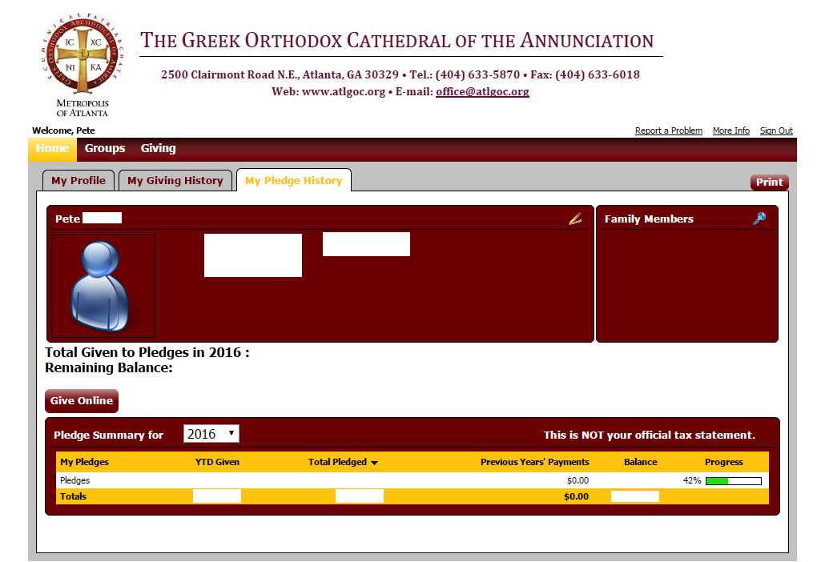
From the Home menu you can visit your profile or account.
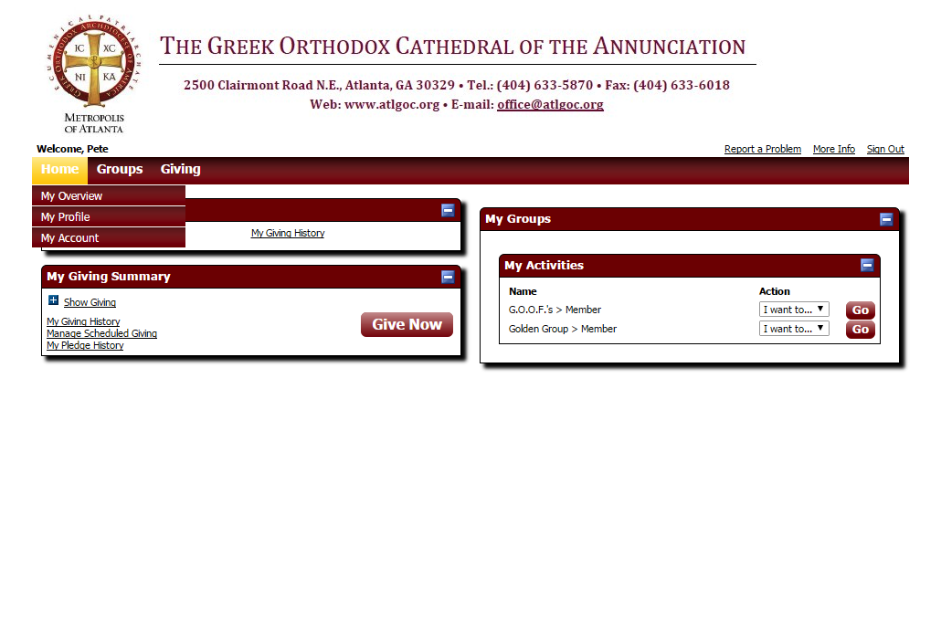
Here is the profile where you can review the phone number and email address that the office has on file for you.
